**Unveiling The Virtual Classroom an In-Depth Analysis of The Online Education System**

**1 INTRODUCTION**

**1.1 Overview**

Online classes and technology have emerged as a superhero during the lockdown days. We have all been under house arrest but are still connected with the world of education. Due to the lockdown, students have not been able to stay connected with the outer world and the lack of exposure is evident. The only reprieve for the students’ mental well-being has been the transition to online classes. Teachers made sure that the learning for students was not compromised, so they took a great leap forward to find solutions and create new learning environments for their students to ensure that learning never stops. With the rapid advancements in technology and the widespread availability of internet access, online education has gained significant popularity in recent years.

**1.2 Purpose**

This project aims to delve deep into the various aspects of online education, examining its strengths, weaknesses, opportunities, and challenges. The outcomes of this project will provide valuable insights for educational institutions, policymakers, and online learning platforms to enhance the effectiveness and accessibility of online education. This analysis of the online education system aims to contribute to the ongoing dialogue on the future of education and help shape a more inclusive, engaging, and effective learning environment in the digital age.

**2 LITERATURE SURVEY**

**2.1 Existing problem**

* **Time Management**
* **Extra Resources**
* **No Recordings of Classes**

**2.2 Proposed solution**

Online classes offer more flexibility, convenience, and access to learning resources than offline classes.

* **Flexible:**
* **Ease of Access**
* **Affordable**
* **Comfortable and convenient**

**3 THEORITICAL ANALYSIS**

**3.1 Block diagram**

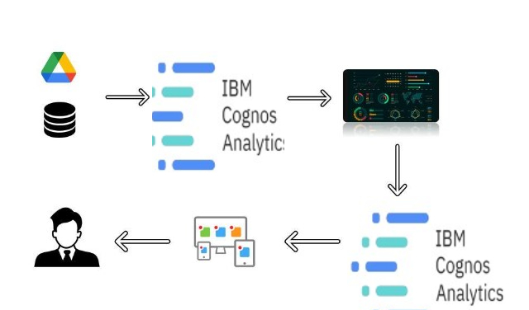

**3.2 Hardware / Software Designing**

* IBM Cloud
* IBM Cognos
* Visual Studio Code

**4 EXPERIMENTAL INVESTIGATIONS**

The experimental investigations yield actionable insights into the potential impact of IBM Cognos Analytics on online education. By analysing student performance, predicting areas of concern, and tailoring learning experiences, the project aims to enhance the overall quality of online education.

**5 FLOWCHART**

**6 RESULTS**

**Online Education Dashboard**

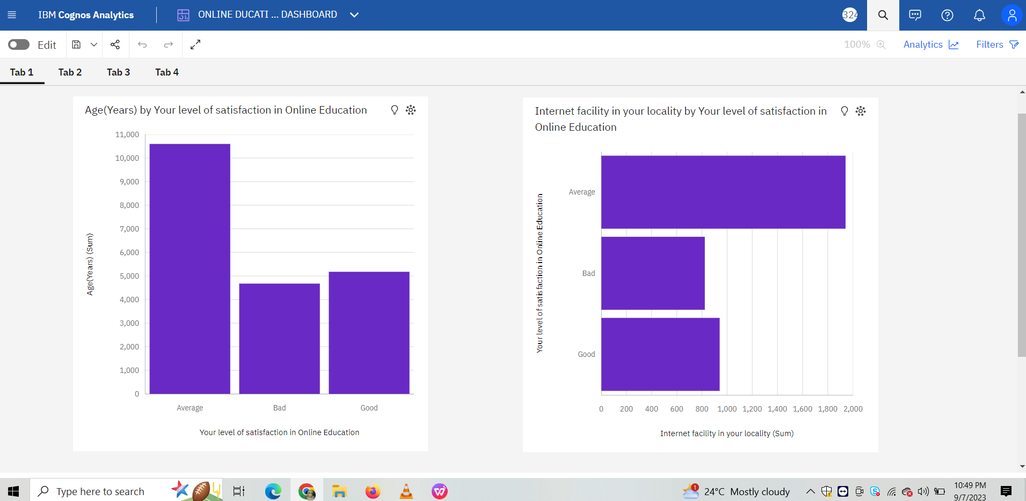

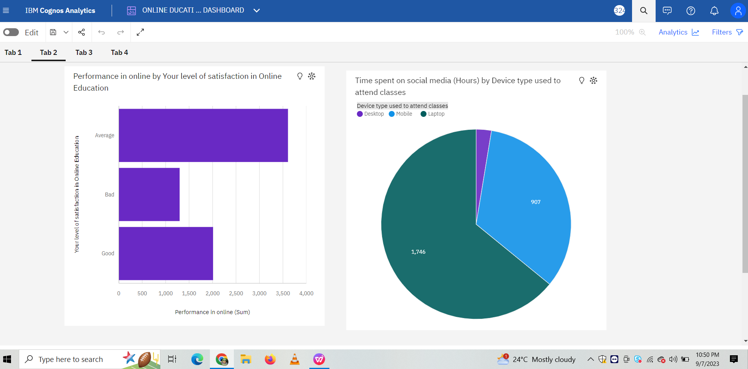

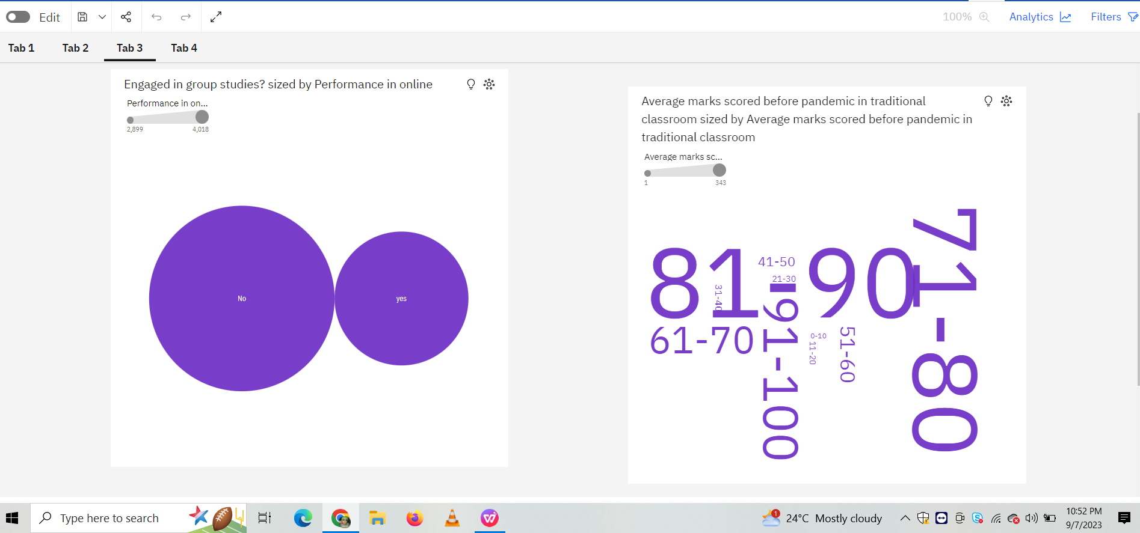

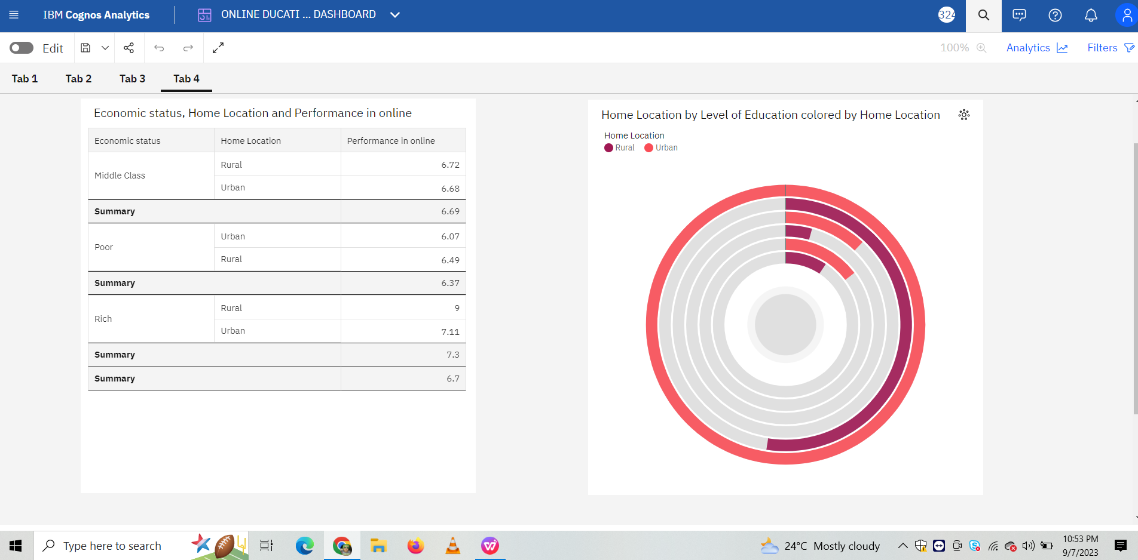

**Online Education Story**

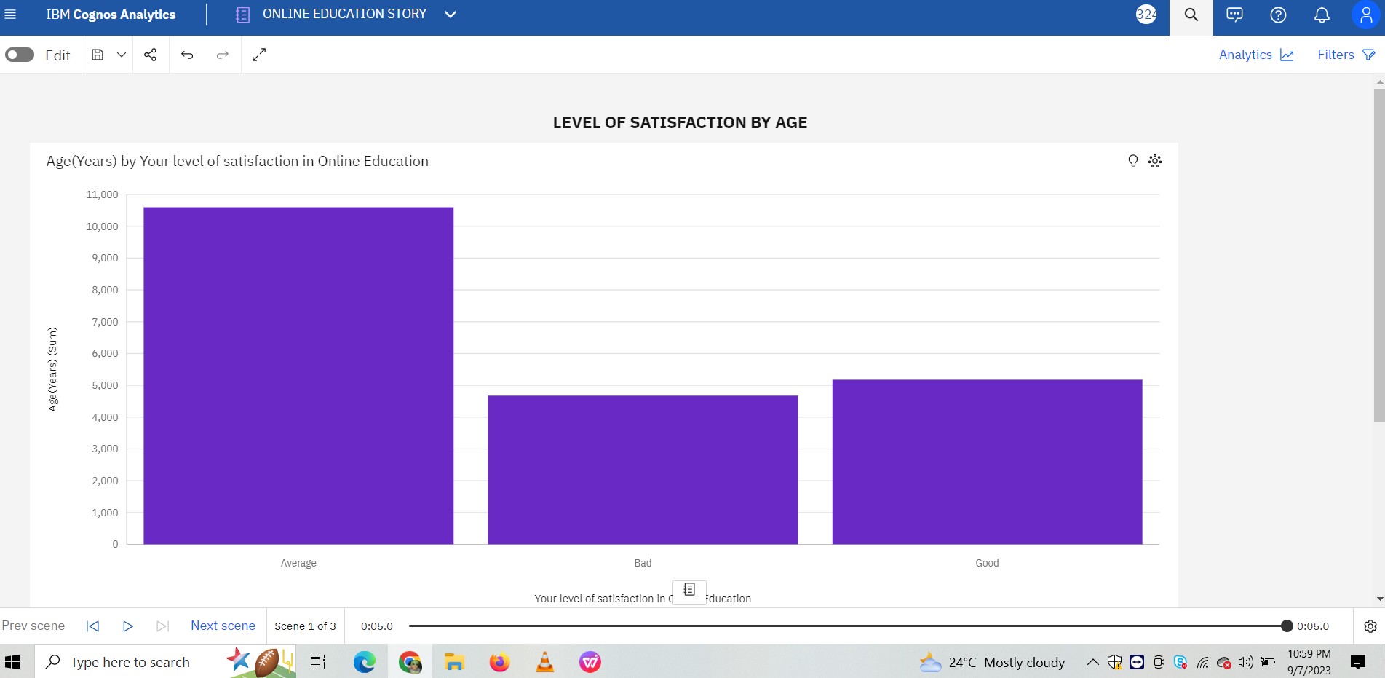

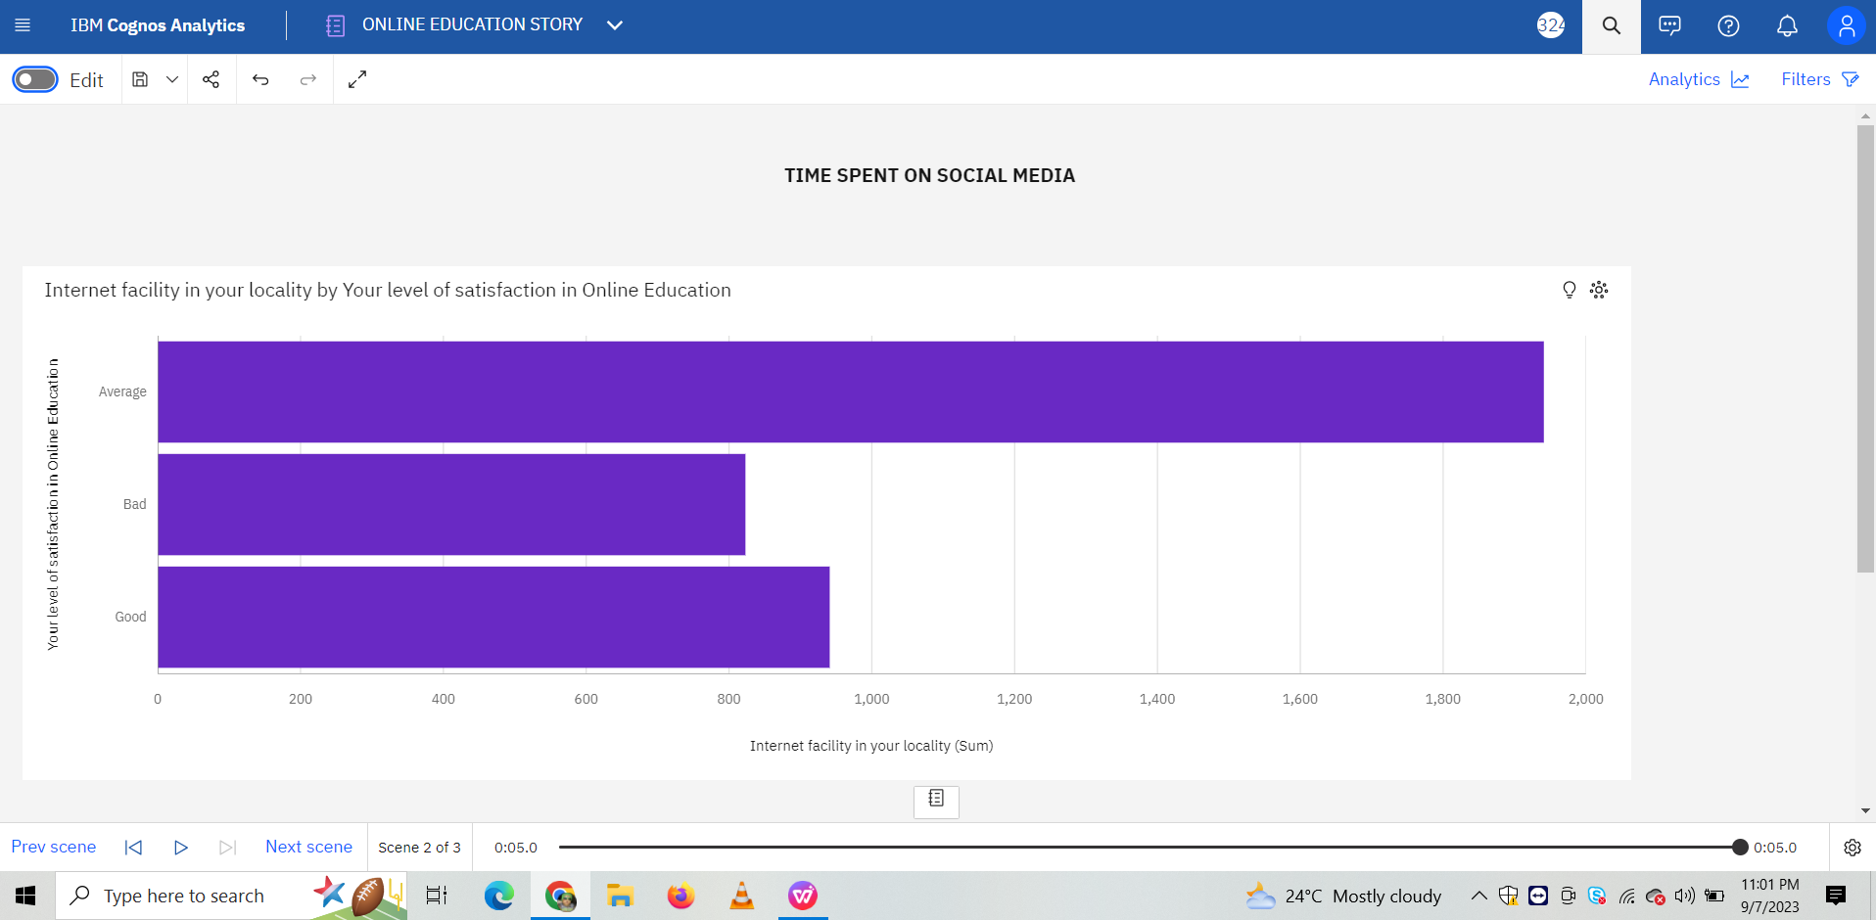

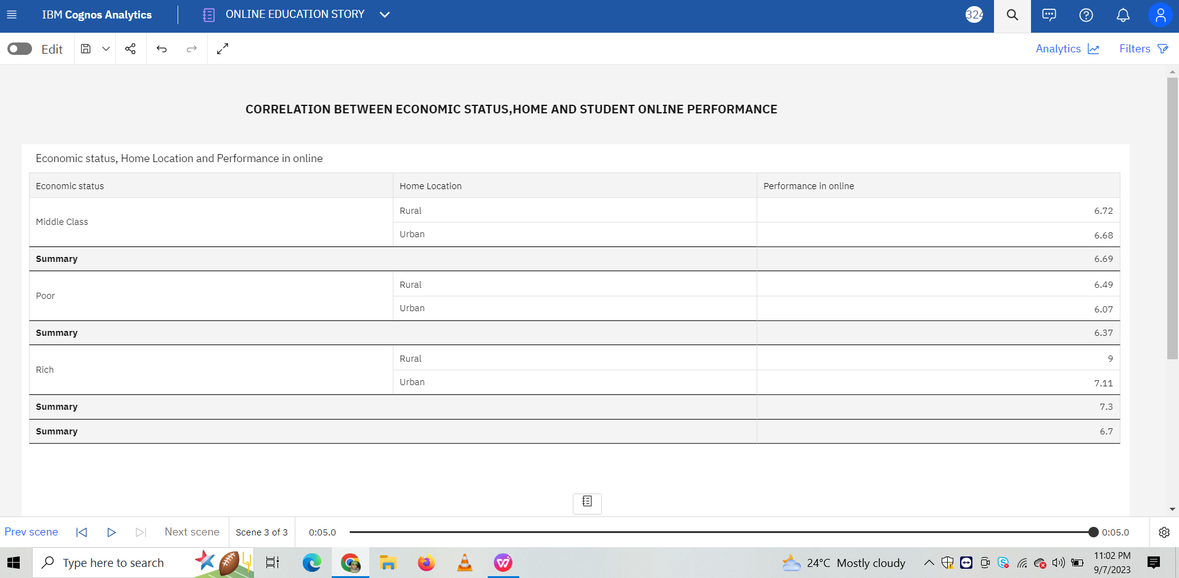

**Online Education Report**

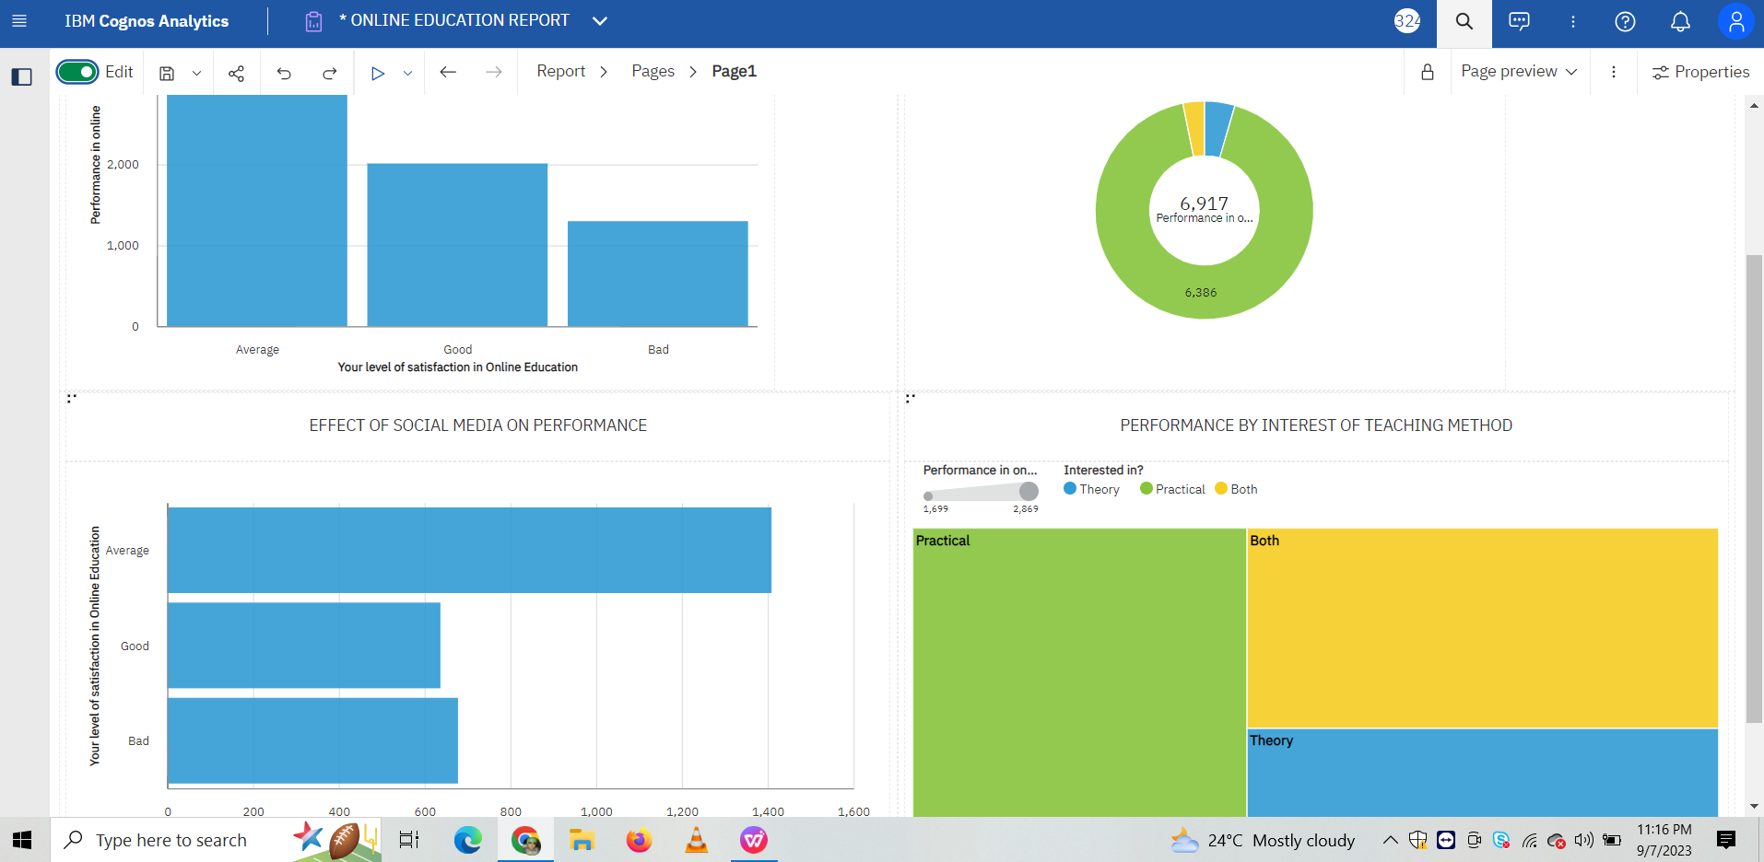

**7 ADVANTAGES & DISADVANTAGES**

**Advantages of Online Education**

* Online classes allow students to be more flexible with their schedules because they can attend classes from the comfort of their own homes.
* Online education is easily available everywhere and at any time if one has a reliable internet connection.
* In comparison to offline school, where fees range from transportation to uniforms, extracurriculars, and a variety of other things, the whole education cost in online education is deducted fairly.
* Because of the reasons stated above, online education is far more convenient than traditional education.

**Disadvantages of Online Education**

* Any connectivity issues that may arise are one of the key downsides of online education.
* For a teacher, one of the major disadvantages of online education is managing student attention.
* Another significant and unavoidable disadvantage of online classes is the amount of time spent in front of the computer.
* Online education, unlike offline education, does not allow students to engage with their peers daily.

**8 APPLICATIONS**

* It can be used in Analyzing the Complexities of Online Education Systems
* The effects of online education on academic success can be studied.
* It aids in Optimization of Online Education and Teaching Evaluation System

**9 CONCLUSION**

The online education system has both pros and cons. IBM Cognos Analytics provides new insights into the key factors of accessibility, educator preparation, and student engagement. Using IBM Cognos Analytics, we can use data to improve these factors and enhance the effectiveness of virtual classrooms.

11 BIBILOGRAPHY

1. J. Chang, "Online Instruction and Offline Classroom Teaching: A Study on Parallel Education Systems," 2021 9th International Conference on Information and Education Technology (ICIET), Okayama, Japan, 2021, pp. 157-160,

doi: 10.1109/ICIET51873.2021.9419638.

1. Cui, Y., Ma, Z., Wang, L., Yang, A., Liu, Q., Kong, S. and Wang, H., 2023. A survey on big data-enabled innovative online education systems during the COVID-19 pandemic. Journal of Innovation & Knowledge, 8(1), p.100295.
2. Online vs Offline Education, Inspiria Knowledge Campus,

https://inspiria.edu.in/online-vs-offline-education-advantages-and-disadvantages/

1. Analyzing the Complexities of Online Education Systems https://link.springer.com/article/10.1007/s11528-020-00538-9.
2. The effects of online education on academic success https://link.springer.com/article/10.1007/s10639-021-10740-8.
3. Optimization of Online Education and Teaching Evaluation System Based https://www.hindawi.com/journals/cin/2021/8785127/.
4. Sustainability | Free Full-Text | The Effectiveness of Online Education. https://www.mdpi.com/2071-1050/13/9/5311.

**APPENDIX**

1. **Index.html**

**<!DOCTYPE html>**

**<html lang="en">**

**<head>**

**<meta charset="utf-8">**

**<meta content="width=device-width, initial-scale=1.0" name="viewport">**

**<title>FlexStart Bootstrap Template - Index</title>**

**<meta content="" name="description">**

**<meta content="" name="keywords">**

**<!-- Favicons -->**

**<link href="assets/img/favicon.png" rel="icon">**

**<link href="assets/img/apple-touch-icon.png" rel="apple-touch-icon">**

**<!-- Google Fonts -->**

**<link href="https://fonts.googleapis.com/css?family=Open+Sans:300,300i,400,400i,600,600i,700,700i|Nunito:300,300i,400,400i,600,600i,700,700i|Poppins:300,300i,400,400i,500,500i,600,600i,700,700i" rel="stylesheet">**

**<!-- Vendor CSS Files -->**

**<link href="assets/vendor/aos/aos.css" rel="stylesheet">**

**<link href="assets/vendor/bootstrap/css/bootstrap.min.css" rel="stylesheet">**

**<link href="assets/vendor/bootstrap-icons/bootstrap-icons.css" rel="stylesheet">**

**<link href="assets/vendor/glightbox/css/glightbox.min.css" rel="stylesheet">**

**<link href="assets/vendor/remixicon/remixicon.css" rel="stylesheet">**

**<link href="assets/vendor/swiper/swiper-bundle.min.css" rel="stylesheet">**

**<!-- Template Main CSS File -->**

**<link href="assets/css/style.css" rel="stylesheet">**

**<!-- =======================================================**

**\* Template Name: FlexStart**

**\* Updated: Aug 30 2023 with Bootstrap v5.3.1**

**\* Template URL: https://bootstrapmade.com/flexstart-bootstrap-startup-template/**

**\* Author: BootstrapMade.com**

**\* License: https://bootstrapmade.com/license/**

**======================================================== -->**

**</head>**

**<body>**

**<!-- ======= Header ======= -->**

**<header id="header" class="header fixed-top">**

**<div class="container-fluid container-xl d-flex align-items-center justify-content-between">**

**<a href="index.html" class="logo d-flex align-items-center">**

**<img src="assets/img/logo.png" alt="">**

**<span>Online Education System</span>**

**</a>**

**<nav id="navbar" class="navbar">**

**<ul>**

**<li><a class="nav-link scrollto active" href="#hero">Home</a></li>**

**<li><a class="nav-link scrollto" href="#about">Report</a></li>**

**<li><a class="nav-link scrollto" href="#services">Dashboard</a></li>**

**<li><a class="nav-link scrollto" href="#portfolio">Story</a></li>**

**<li><a class="nav-link scrollto" href="#contact">Contact</a></li>**

**<li><a class="getstarted scrollto" href="#about">Get Started</a></li>**

**</ul>**

**<i class="bi bi-list mobile-nav-toggle"></i>**

**</nav><!-- .navbar -->**

**</div>**

**</header><!-- End Header -->**

**<!-- ======= Hero Section ======= -->**

**<section id="hero" class="hero d-flex align-items-center">**

**<div class="container">**

**<div class="row">**

**<div class="col-lg-6 d-flex flex-column justify-content-center">**

**<h1 data-aos="fade-up">Unveiling The Virtual Classroom: An In-Depth Analysis Of The Online Education System</h1>**

**<h2 data-aos="fade-up" data-aos-delay="400">Online classes and technology have emerged as a superhero during the lockdown days. We have all been under house arrest but are still connected with the world of education. The only reprieve for the students’ mental well-being has been the transition to online classes.</h2>**

**<div data-aos="fade-up" data-aos-delay="600">**

**<div class="text-center text-lg-start">**

**<a href="#about" class="btn-get-started scrollto d-inline-flex align-items-center justify-content-center align-self-center">**

**<span>Get Started</span>**

**<i class="bi bi-arrow-right"></i>**

**</a>**

**</div>**

**</div>**

**</div>**

**<div class="col-lg-6 hero-img" data-aos="zoom-out" data-aos-delay="200">**

**<img src="assets/img/hero-img.png" class="img-fluid" alt="">**

**</div>**

**</div>**

**</div>**

**</section><!-- End Hero -->**

**<main id="main">**

**<!-- ======= About Section ======= -->**

**<section id="about" class="about">**

**<div class="container" data-aos="fade-up">**

**<div class="row gx-0">**

**<iframe src="https://us3.ca.analytics.ibm.com/bi/?pathRef=.my_folders%2FONLINE%2BEDUCATION%2BREPORT&amp;closeWindowOnLastView=true&amp;ui_appbar=false&amp;ui_navbar=false&amp;shareMode=embedded&amp;action=run&amp;format=HTML&amp;prompt=false" width="320" height="200" frameborder="0" gesture="media" allow="encrypted-media" allowfullscreen=""></iframe>**

**</div>**

**<div class="col-lg-6 d-flex align-items-center" data-aos="zoom-out" data-aos-delay="200">**

**<img src="assets/img/about.jpg" class="img-fluid" alt="">**

**</div>**

**</div>**

**</div>**

**</section><!-- End About Section -->**

**<!-- ======= Services Section ======= -->**

**<section id="services" class="services">**

**<div class="container" data-aos="fade-up">**

**<iframe src="https://us3.ca.analytics.ibm.com/bi/?perspective=dashboard&amp;pathRef=.my_folders%2FONLINE%2BDUCATION%2BDASHBOARD&amp;closeWindowOnLastView=true&amp;ui_appbar=false&amp;ui_navbar=false&amp;shareMode=embedded&amp;action=view&amp;mode=dashboard&amp;subView=model0000018a69124e02_00000003" width="320" height="200" frameborder="0" gesture="media" allow="encrypted-media" allowfullscreen=""></iframe>**

**</div>**

**</div>**

**</section><!-- End Services Section -->**

**<!-- ======= Portfolio Section ======= -->**

**<section id="portfolio" class="portfolio">**

**<div class="container" data-aos="fade-up">**

**<iframe src="https://us3.ca.analytics.ibm.com/bi/?perspective=story&amp;pathRef=.my_folders%2FONLINE%2BEDUCATION%2BSTORY&amp;closeWindowOnLastView=true&amp;ui_appbar=false&amp;ui_navbar=false&amp;shareMode=embedded&amp;action=view&amp;sceneId=model0000018a6915a924_00000003&amp;sceneTime=0" width="320" height="200" frameborder="0" gesture="media" allow="encrypted-media" allowfullscreen=""></iframe>**

**</div>**

**</div>**

**</section><!-- End Portfolio Section -->**

**<!-- ======= Contact Section ======= -->**

**<section id="contact" class="contact">**

**<div class="container" data-aos="fade-up">**

**<header class="section-header">**

**<h2>Contact</h2>**

**<p>Contact Us</p>**

**</header>**

**<div class="row gy-4">**

**<div class="col-lg-6">**

**<div class="row gy-4">**

**<div class="col-md-6">**

**<div class="info-box">**

**<i class="bi bi-geo-alt"></i>**

**<h3>Address</h3>**

**<p>Hyderabad<br>Telangana, India 500070</p>**

**</div>**

**</div>**

**<div class="col-md-6">**

**<div class="info-box">**

**<i class="bi bi-telephone"></i>**

**<h3>Call Us</h3>**

**<p>+91 8500088390</p>**

**</div>**

**</div>**

**<div class="col-md-6">**

**<div class="info-box">**

**<i class="bi bi-envelope"></i>**

**<h3>Email Us</h3>**

**<p>vasavibvs@methodist.edu.in</p>**

**</div>**

**</div>**

**<div class="col-md-6">**

**<div class="info-box">**

**<i class="bi bi-clock"></i>**

**<h3>Open Hours</h3>**

**<p>Monday - Friday<br>9:00AM - 05:00PM</p>**

**</div>**

**</div>**

**</div>**

**</div>**

**<div class="col-lg-6">**

**<form action="forms/contact.php" method="post" class="php-email-form">**

**<div class="row gy-4">**

**<div class="col-md-6">**

**<input type="text" name="name" class="form-control" placeholder="Your Name" required>**

**</div>**

**<div class="col-md-6 ">**

**<input type="email" class="form-control" name="email" placeholder="Your Email" required>**

**</div>**

**<div class="col-md-12">**

**<input type="text" class="form-control" name="subject" placeholder="Subject" required>**

**</div>**

**<div class="col-md-12">**

**<textarea class="form-control" name="message" rows="6" placeholder="Message" required></textarea>**

**</div>**

**<div class="col-md-12 text-center">**

**<div class="loading">Loading</div>**

**<div class="error-message"></div>**

**<div class="sent-message">Your message has been sent. Thank you!</div>**

**<button type="submit">Send Message</button>**

**</div>**

**</div>**

**</form>**

**</div>**

**</div>**

**</div>**

**</section><!-- End Contact Section -->**

**</main><!-- End #main -->**

**<a href="#" class="back-to-top d-flex align-items-center justify-content-center"><i class="bi bi-arrow-up-short"></i></a>**

**<!-- Vendor JS Files -->**

**<script src="assets/vendor/purecounter/purecounter_vanilla.js"></script>**

**<script src="assets/vendor/aos/aos.js"></script>**

**<script src="assets/vendor/bootstrap/js/bootstrap.bundle.min.js"></script>**

**<script src="assets/vendor/glightbox/js/glightbox.min.js"></script>**

**<script src="assets/vendor/isotope-layout/isotope.pkgd.min.js"></script>**

**<script src="assets/vendor/swiper/swiper-bundle.min.js"></script>**

**<script src="assets/vendor/php-email-form/validate.js"></script>**

**<!-- Template Main JS File -->**

**<script src="assets/js/main.js"></script>**

**</body>**

**</html>**

1. **App.py**

**from flask import Flask, render_template**

**app = Flask(__name__)**

**@app.route("/")**

**def home():**

**return render_template(r"index.html")**

**if __name__ == "__main__":**

**app.run(debug=False, port=5000)**